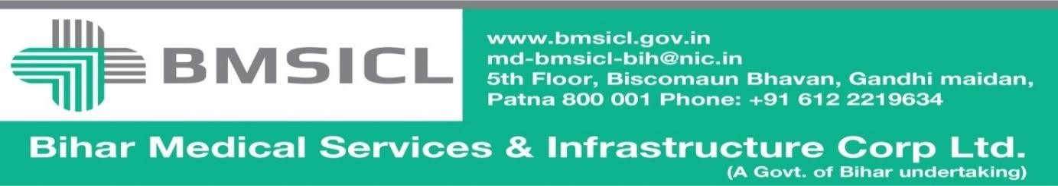

Corrigendum-2

Bihar Medical Services and Infrastructure Corporation Limited (BMSICL) invited E-Bids from the interested parties regarding tender for the supply of Medical Equipment for different Govt. Medical Colleges and Hospitals of Bihar vide Notice Inviting Tender No.-BMSICL/2017-18/ME-067. A Pre-bid meeting was held on 16/10/2017 during and after which various suggestions were received from prospective bidders for amendment in technical specification and accordingly some amendment have been made as per the Annexure-I of this corrigendum. In order to facilitate the wider participation of bidders, the tender schedule is being revised as follows:-
Tender Reference No. | BMSICL/2017-18/ME-067
Date and time for downloading of bid document | 06th December 2017 till 17:00 Hrs.
Last date and time of submission of online bids | 08th December 2017 upto 17:00 Hrs.
Last date and time for submission of original documents of EMD and Document Fee | 12th December 2017 till 14:00 Hrs.
Date, Time and Place of opening of Technical Bid | 12th December 2017 (at 15:00 Hrs.) on the website of www.eproc.bihar.gov.in in the office of BMSICL
Date and time of opening of financial Bids | To be announced later on www.eproc.bihar.gov.in

Note:- Please refer to the Annexure- I of this corrigendum before submission of bid.

Sd/-
GM (Procurement)
BMSICL

