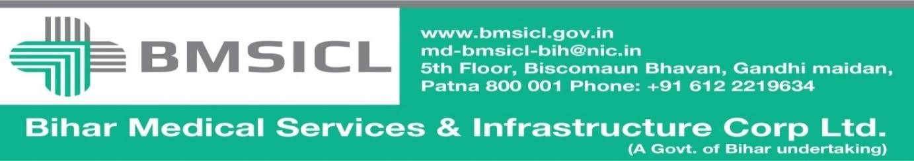

Corrigendum-I

Bihar Medical Services and Infrastructure Corporation Limited (BMSICL) invited E-Bids from the interested parties regarding tender for the supply of Medical Equipment for different Govt. Medical Colleges and Hospitals of Bihar vide Notice Inviting Tender No.-BMSICL/2017-18/ME-067. A Pre-bid meeting was held on 16/10/2017 during and after which various suggestions were received from prospective bidders for amendment in technical specification. In order to facilitate the wider participation of bidders, the tender schedule is being revised as follows:-
Tender Reference No. | BMSICL/2017-18/ME-067
Date and time for downloading of bid document | 22nd November 2017 till 17:00 Hrs.
Last date and time of submission of online bids | 24th November 2017 upto 17:00 Hrs.
Last date and time for submission of original documents of EMD and Document Fee | 27th November 2017 till 14:00 Hrs.
Date, Time and Place of opening of Technical Bid | 27th November 2017 (at 15:00 Hrs.) on the website of www.eproc.bihar.gov.inin the office of BMSICL
Date and time of opening of financial Bids | To be announced later on www.eproc.bihar.gov.in

Sd/-
GM (Procurement)
BMSICL

