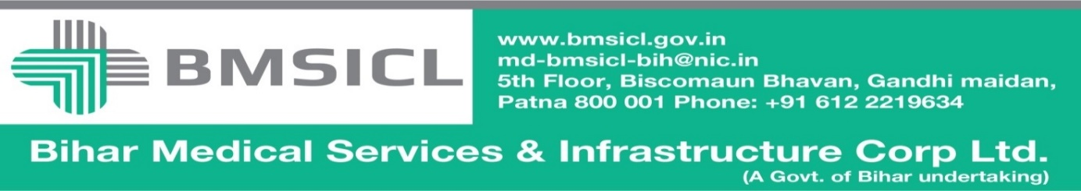

RE-TENDER NOTICE

Notice Inviting E-Bids
The Bihar Medical Services and Infrastructure Corporation Limited, Patna invites e-bids from interested parties for installation, operation and maintenance of CT Scan machine under Public Private Partnership (PPP) Mode for ANMMCH Gaya, JLNMCH Bhagalpur, VIMS Pawapuri and Bettiah Medical College and Hospital of Bihar
Notice Inviting RE-Tender Ref No.BMSICL/2017-18/ME-062 Dated: -07-2017

(Only through E- Tender on website:-www.eproc.bihar.gov.in)

Tender Schedule
Tender Reference No. | BMSICL/2017-18/ME-062
Date and time for downloading of bid document from www.eproc.bihar.gov.in | 07th July 2017 from 10:00 Hrs. to 28th july 2017 till 15:00 Hrs.
Date of Pre- Bid Meeting | 14th july 2017 at 15:00Hrs in Conference hall of BMSICL. 5th Floor , Biscomaun Bhawan
Last date and time of submission of online bids | 31st July 2017 by 13:00 Hrs.
Last date and time for submission of original documents of EMD and Document Fee | 02nd August 2017 until 14:00 Hrs.
Date, Time and Place of opening of Technical Bid | 02nd August 2017 (at 15:00 Hrs.) on the website of www.eproc.bihar.gov.in in the office of BMSICL
Date and time of opening of financial Bids | To be announced later on www.eproc.bihar.gov.in
Validity of Tender | 180 Days
Cost of the tender document | Rs. 10000/- (Ten Thousand Rupees only) Non-refundable.
Bid Processing Fee | Rs 1150/-

Note:- 1. Bidding Documents containing detailed Technical Specifications along with eligibility criteria, selection mechanism, other terms and conditions will be available on the website www.eproc.bihar.gov.in.

GM (Procurement)

2. To participate in E-Tendering the tenderer will have to be registered with E-Tendering service provider. For this help desk first floor, M/22, Bank of India building, Road no.-25, Sri Krishna Nagar Patna-800020, Tele Phone no.-0612-2523006, Mobile No. - 7542028164 can be approached.

3. The cost of tender document is acceptable as Bank Draft issued by any nationalized bank in favour of Managing Director, Bihar Medical Services and Infrastructure Corporation Limited, Patna and payable at Patna and it is non-refundable.

4. The required amount of Earnest Money is acceptable in the form of Bank Draft issued by nationalized and schedule bank in favour of Managing Director, Bihar Medical Services and Infrastructure Corporation Limited, Patna and payable at Patna. The Earnest Money deposited in any other form shall not be acceptable.

5. The Tender Inviting Authority reserves the right to extend the schedule of tender or to reject the tender without assigning any reason.

6. The fee of bid processing is to be deposited by the tenderer through net banking i.e. RTGS/NEFT/Debit Card. The tenderer must ensure the payment before schedule time otherwise in last moment for delay payment the corporation will not be responsible.

7.It is essential to deposit the original documents of Tender fee, EMD, Technical Bid of quoted item in sealed envelope at Bihar Medical Services Infrastructure Corporation Limited, Patna by 02nd August 2017 at 14:00 Hrs.

8. Note: Please number the documents with serial number on each and every page and do mention the total number of pages of bidding document. In technical Bid parallel assign the corresponding page numbers of supporting documents. Any discrepancy or misrepresentation in this respect will not be entertained.

9. Any queries and questions regarding the tender should be addressed to MD BMSICL (either through letter or through e-mail:- md-bmsicl-bih@nic.in) up to 7 days before closing of online bid registration.

10. All communication, addendum/corrigendum related to this tender will be issued on the website of www.eproc.bihar.gov.in& / www.bmsicl.gov.in.

11. Managing Director, BMSICL reserves the right to reject any or all the applications without assigning any reason.

GM (Procurement),
BMSICL

